No | DATE | TASK | TICK
1 | 09.02.24  Friday  P4  HOMEWORK  DUE: 19.02.24 | 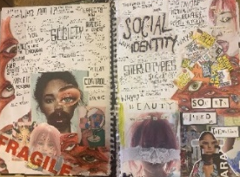  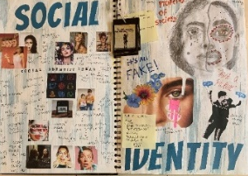  TASK 1: Visual Mind Map AO1  SUCCESS CRITERIA:  - Background  - Clear chosen theme (title of the mind map)  - Mind Map with lots of ideas considered  - Artist images  - Pinterest images  - Own images related to the theme  - Drawings/Paintings  - Creative page presentation  - Fill the whole double page  - Present images large to fill spaces  Pick a theme within OBSERVE, SEEK, CHALLENGE and present this as your visual mind map.
2 | HOMEWORK  DUE: 19.02.24 | TASK 2: PowerPoint AO1  Create a PPT with 4 slides researching your chosen theme. Present this as the second double page in your sketchbook.  SLIDE 1: Chosen theme: Write about why you have chosen this theme and what you want to explore/research as part of the theme. Include images that inspire you for this theme.  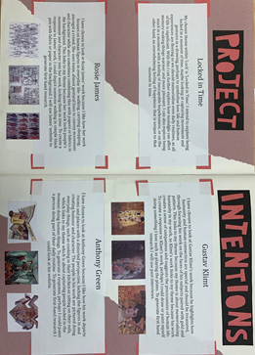  SLIDE 2 - 3 Artists: Write about who they are and why you have chosen them to relate to your chosen theme. Include images of their artwork.  SUCCESS CRITERIA:  - Print out in colour and present as the second double page in your sketchbook  - Add a creative background and present the full slides on the page  - Make sure you cut straight  - Stick all edges down  - Refined presentation  - Include lots of images and some drawings on the page
 | 19.02.24  Monday P5  20.02.24 Tuesday  P1 & P3  21.02.24  Wednesday P4  22.02.24  Thursday  P1 & 4  HOMEWORK: Artist 1  DUE:26.02.24 | 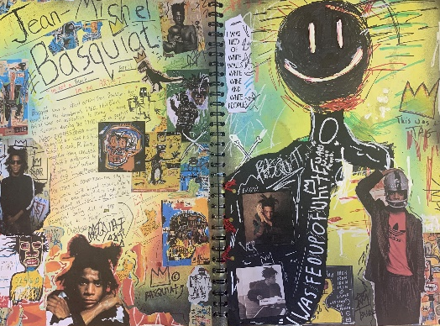  TASK 3: Artist Research Section AO1 & AO3  Double page for each artist. Aim for several artists pages so you can explore your theme in detail to build ideas  SUCCESS CRITERIA:  - Double page  - Fill the page  - Large scale response over a double page/middle of page  - Detailed/sustained artist response (your copy of their work)  - 5-6 images of their work  - Written analysis of the work using PEE giving your opinion (use the annotation sheet)  - Basic information and facts about the artist
  26.02.24  Monday P3  Artist 2 | 29.02.24  Thursday P3  Artist 2 | 01.03.24  Friday P4  Artist 2 | 04.03.24  Monday P5  Artist 3 | 05.03.24  Tuesday  P1 & P3  Artist 3 | 06.03.24  Wednesday P4  Artist 3 | 07.03.24  Thursday  P1 & 4  Artist 3
 | HOMEWORK  DUE:  26.02.24 | 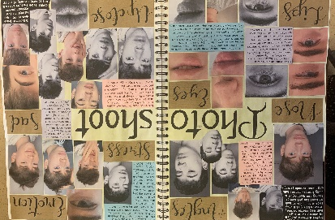  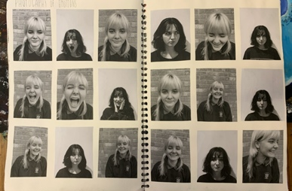  TASK 4: Contact Sheet A03  Double page including own images related to chosen theme and artists  SUCCESS CRITERIA:  - Own photos  - Clean background  - Experiments with different lighting  - Zoom in and out  - Different angles
3 | 11.03.24  Monday  P3  14.03.24  Thursday  P3  15.03.24  Friday  P4  HOMEWORK DUE: 18.03.24 | TASK 5: Observational Drawing AO3  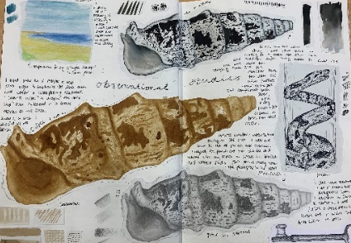  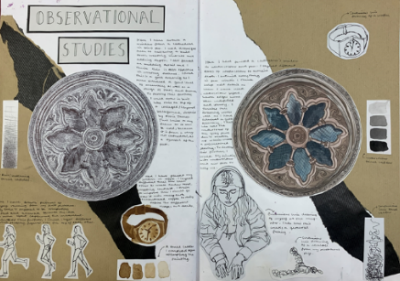  A double page with a range of drawings that best show your theme of ‘OBSERVE, SEEK, CHALLENGE’  SUCCESS CRITERIA:  - Range of materials  - Range of techniques  - Fill the page  - Include annotation  - Include starter booklet - expressive medias
5 | 18.03.24  Monday P3 &4  29.03.24  Tuesday  P1 & 3  20.03.24  Wednesday  P4  HOMEWORK  DUE:  11.04.24 | 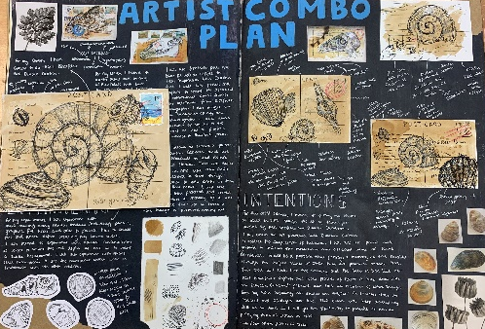  TASK 6: Artist Combo’s & Outcomes AO2 & AO4  - Double page planning how you can mix combine the artists in different ways using your own images as the base of the artist combo.  SUCCESS CRITERIA:  - Mind map  - Artist images  - Sketches  - Materials  - Own photos  - A4 mini version - evaluated  - A2 Artist Combo out of the sketchbook – 5 hours to complete. Evaluation of outcome
EASTER HOLIDAYS
TASK 1: ARTIST COMBO OUTCOME (5 HOURS)
TASK 2: DIRT
 | 08.04.24  Monday P3  11.04.24  Thursday  P3  12.04.24  Friday  P4  15.04.24  Monday  P3 & 4  HOMEWORK  DUE: 22.04.24 | TASK 7: Final Piece Development Planning Page AO2  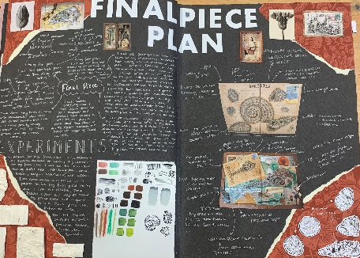  Introduce a range of techniques to help develop your idea further. Focus on developing ideas for backgrounds/composition/refinement/link to theme and artist.  SUCCESS CRITERIA:  - Rage of responses as well as smaller experiments exploring different materials/compositions/ideas etc.  - Annotations to explain ideas  - Material swatches to be included  - Own photos  - Test out lots of different ideas in different materials
 | 22.04.24  Monday P3  25.04.24  Thursday P 3  26.04.24  Friday P4  Homework Due: 29.04.24 | TASK 8: Experiments  Over a double page produce 5 x experiments that explore:  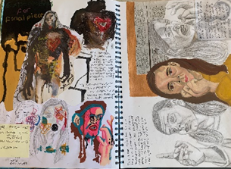  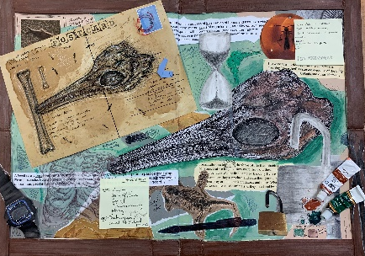  - Different techniques  - Composition/layout  - Ideas  - Media  - Annotate each one
6 | 30.04.24  Tuesday P3  01.05.24  Wednesday  P3  02.05.24  Thursday P1 & 4  HOMEWORK DUE:  09.05.24 | TASK 9: MINI FINAL PIECE AO2 & AO4  Create a mini final piece based on your best experiments and developments.  This should be no smaller than A4  Test out the composition, scale, materials and techniques you want to use to see if it is successful as an outcome  (Missed lesson due to bank holiday)
7 | 10.05.24  13.05.24  15.05.24 | TASK 10: EXAM: FINAL OUTCOME/S A04. 10 hours  Create a final outcome that ties all your project together. Work out of the book on A2 larger.  SUCCESS CRITERIA:  - Bring together all project influences to create a refined, exciting, creative final piece  - Final piece should summarise all influences throughout the project and should clearly link to sketchbook/ideas throughout  Be BOLD! GO BIG! GO FOR IT!!!

