Year 13 French Revision Checklist (Jan 2024)
Year 12 | 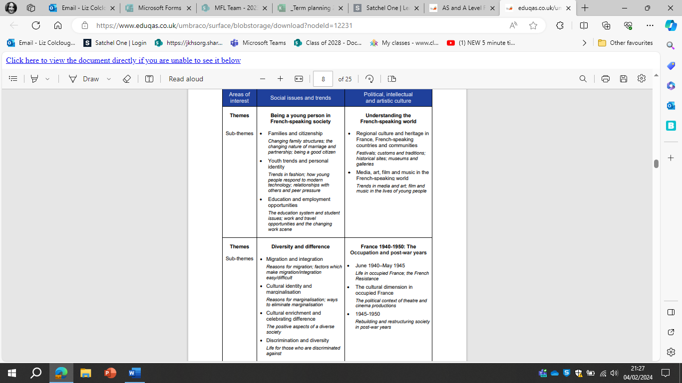
Year 13

Grammatical content, appropriate to French Learners will be expected to have studied the grammatical system and structures of the language during their course. Knowledge of the grammar and structures specified for GCSE is assumed.
In the examination learners will be required to use, actively and accurately, grammar and structures appropriate to the tasks set, drawn from the following lists. The mention of an item in these lists implies knowledge of both its forms and its functions at an appropriate level of accuracy and complexity.
The examples in italics in parentheses are indicative; that is, they serve to illustrate the part of speech or structure that the candidate must know and hence do not represent an exhaustive specification of the required grammatical knowledge. For items marked (R), receptive knowledge only is required.

Nouns
-Gender
-Singular and plural forms

Articles
- Definite, indefinite and partitive
Adjectives
-Agreement
-Position
-Comparative and superlative
-Use of adjectives as nouns (e.g. le vieux, les Anglais)
-Demonstrative (ce, cet, cette, ces)
-Indefinite (including autre, chaque, même, quelque)
-Possessive (mon, ma, mes, etc.)
-Interrogative and exclamatory (quel, quelle, quels, quelles)
Numerals
-Cardinal (e.g. un, deux)
-Ordinal (e.g. premier, deuxième)
-Expression of time and date
Adverbs
-Formation of adverbs in -ment
-Comparative and superlative
-Interrogative (including combien (de), comment, où, pourquoi, quand)
Quantifiers/intensifiers
-(including assez, beaucoup, moins, plus, la plupart, plusieurs, presque, tant, très, trop)
Pronouns
-Personal: subject, including on
-Object: direct and indirect
-Disjunctive/emphatic personal, as subject and object: moi/moi-même, etc.
-Position and order
-Reflexive
-Relative (including qui, que, dont, lequel
etc., auquel etc., ce qui, ce que)
-Demonstrative (celui, celle, ceux, celles; and celui-ci/celui-là etc.)
-Indefinite (including quelqu’un, quelque chose)
-Possessive (le mien etc.)
-Interrogative (including qui, que, quoi)
-Use of y, en
Verbs
-Conjugation of regular -er, -ir, -re verbs, modal verbs, principal irregular verbs, including reflexive verbs
-Agreement of verb and subject Use of il y a
-Modes of address (tu, vous)
-Impersonal verbs
-Constructions with verbs
-Verbs followed by an infinitive (with or without a preposition)
-Perfect infinitive
-Negative forms
-Interrogative forms
-Use of tenses
Present Perfect (including agreement of past participle)
Imperfect
Future
Conditional
Future perfect
Conditional perfect
Pluperfect
Past historic (R)
-Use of the infinitive, present participle (e.g. en arrivant) and past participle
-Verbal paraphrases and their uses
(including aller + infinitive, venir de + infinitive)
-Subjunctive mood:
present (common uses, for example, after expressions of possibility, necessity, obligation and after conjunctions such as bien que) perfect tense imperfect tense (R)
-Dependent infinitives (faire réparer)
-Passive voice: all tenses
Prepositions
-All prepositions, both simple (e.g. sous) and complex (e.g. au-delà de)
Conjunctions
-Coordinating conjunctions (e.g. et, ou, mais)
-Subordinating conjunctions
Negation
-Use of negative particles (e.g. ne...pas, ne...personne, ne...que)
-Use of ne with negative subjects (e.g. Personne n’est venu)
Questions
Commands
Word order
Inversion after speech
Inversion after adverbs
Other constructions
-Time expressions with depuis and il y a
-Comparative constructions
-Indirect speech
Discourse markers (e.g. Au contraire, En fait)
Fillers (e.g. alors, bon)

Topics:
Year 12
1 - La famille en voie de changement | La vie de couple: nouvelles tendances  Monoparentalité, homoparentalité, familles recomposées  Grands-parents, parents et enfants : soucis et problèmes
2 - La cyber-société | Comment la technologie facilite la vie quotidienne  Quels dangers la cyber-société pose-t-elle ?  Qui sont les cybernautes ?
3. Youth culture, fashion, Music and T.V. | The roles and attitudes of image and fashion  Peer pressure and values  The role of film/music/theatre and festivals  Film and TV  Modes of communication  Free time /Sport
4 - Le Lycée, et après  Le monde du travail ? | French school system  School issues  Career choices, job opportunities and unemployment  Equal opportunities  Changing work scene
5 Une culture fière de son patrimoine | Le patrimoine sur le plan national, régional et local  Le patrimoine et le tourisme  Comment le patrimoine reflète la culture
6. La musique francophone contemporaine | La diversité de la musique francophone contemporaine  Qui écoute et apprécie la musique francophone contemporaine  Comment sauvegarder la musique francophone contemporaine
7. Le septième art | Pourquoi septième art?  Evolution du cinéma : les grandes lignes  Le cinéma : une passion nationale
8. Film  Intouchables | Analyse French films  Analyse French texts  Writing essays about French films/books.
Year 13
1. Les aspects positifs d’une société diverse | L’enrichissement dû à la mixité ethnique  Diversité, tolérance et respect  Diversité – un apprentissage pour la vie
2. Quelle vie pour les marginalisés?  Discrimination and diversity | Qui sont les marginalisés ?  Quelle aide pour les marginalisés ?  Quelles attitudes envers les marginalisés ?  Quelles attitudes envers la criminalité
3. La politique et l’immigration | Solutions politiques à la question de l’immigration  L’immigration et les partis politiques  L’engagement politique chez les immigrés
4. June 1940–May 1945  La France occupée  Life in occupied France; the French  Resistance | La France sous l’Occupation et la collaboration  L’antisémitisme et l’Occupation  La vie sous l’Occupation 4.4 Le maréchal Pétain et le régime de Vichy  La Révolution nationale  la politique de Vichy et ses conséquences  La Résistance  l’importance de Jean Moulin et des femmes de la Résistance  Les Français libres et le général Charles de Gaulle
5. 1945–1950  L’après-guerre  Rebuilding and restructuring society  in post-war years | Les représailles d’après-guerre  Les femmes tondues  Les 30 glorieuses -la reconstruction du pays et l’immigration  La IVe République  Le parti communiste  La création de l’OTAN
7. Literature /film  Vercors: Le silence de la mer  A novel (1942)  Mathieu Kassovitz: La Haine  A feature film (1995) | Analyse French films  Analyse French texts  Writing essays about French films/books.

