Strategies to Support Effective Revision

There is some flexibility in how you do these stages but if you follow them all you should be revising effectively.
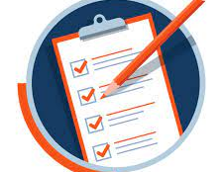
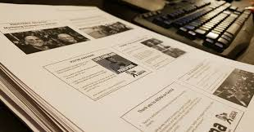
- Gather you RESOURCES for the subject/topic. This means having the handouts/booklets /textbooks/revision lists that you need in order to revise the topic. If you are unsure about this, ask your teacher what they expect you to be revising from………… what resources do they want you to use to create your condensed revision notes.

- Chunk up the resources into manageable sized sections and READ over the material for the section/topic you want to revise. You may choose to read over a summary section or overview PPT handout first. Don’t try and read too much! The point of reading it over is to
- Engage your brain in the topic

- Ensure you understand the content
If you start drifting off – Stop and think about what you have just read.
If you do not understand any of the content you cannot write it into your revision notes. If this is the case, make a note and ask your teacher to explain.
REMEMBER you usually don’t need to know everything you read in the topic – the reading is giving you an idea of the KEY POINTS you will want to make a note of in your revision.
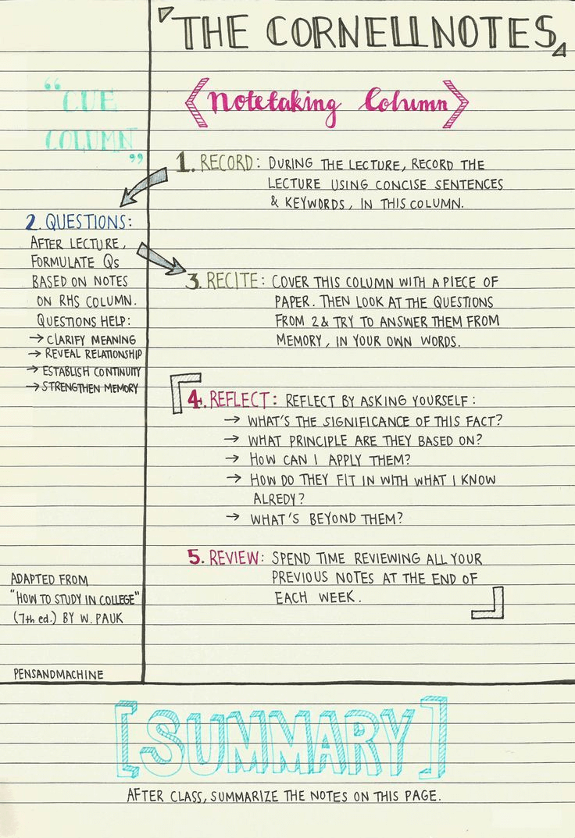
- Create your REVISION NOTES. You will find what works for you and the format of your revision notes may vary depending on the subject and even the specific topic.
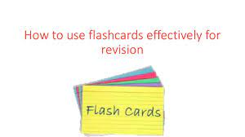
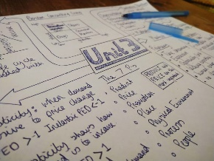
- Mind maps
- Listed notes on A4
- Flash cards
- Cornell notes
The most important things regarding your revision notes are the following:-
- Avoid copying out sentences from your resources/booklet/handout.
- Pick Key points and always leave lines/spaces between the key points.
- Use Underlining, Bullet points, indentation, Stars, Boxes, arrows, pictures…..
- Try a develop a “shorthand” so some words/key terms/names can be abbreviated
The most important thing is that the key points are clearly visible for your brain to recall them when you do not have the notes in front of you – this is why you should leave plenty of spaces and be prepared to use a lot of paper!!
- RECALL! The most important part. Once you have made some revision notes, put them to one side/turn them over. See what you can remember, try saying it over to yourself. Visualise the paper and what is on it. Notice what you could remember and what you could not. Is some of the content easier to recall – why? Adapt your revision notes, make it better.
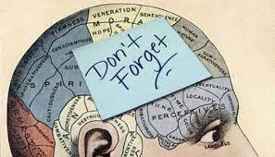
RECALL:
You can talk it through out loud or in your head and then look back at the notes to check what you forgot.

You can re-write some notes – these can be scruffy and thrown away afterwards if you like – it’s just a way of checking what you could remember.
You can work with someone else and test each other.
Keep working at regular intervals on your recall of different topics until it is all available to you inside your head!

- Apply what you have revised to exam technique.
The final part of effective revision is to apply it to exam questions.
For subjects such as Maths and some Science you may be able to get to this point more quickly because there is less content to read over as part of the revision.
Even with Maths and Science there will be topics you need to make revision notes on, steps 1-4.

For all subjects you need to be familiar with the way exam papers are structured and the way questions are worded. It will benefit you to understand the way marks are awarded, for example for AO1 knowledge of topic content, AO2 the way you have applied the knowledge to the question, or AO3 analysis and evaluation, have you shown the ability to critically understand and evaluate the topic. Some subjects may use different language for these ideas but as a student it is important you understand: -
- What the exam will look like
- What sort of questions you will be answering (and their command words)
- HOW to structure your answers…

It will be useful for you to have lists of Past Paper Questions (PPQs)
Some subjects will give you these which saves wasting time and paper printing off masses of PPQs! Be careful of printing off Mark Schemes for some subjects (less scientific subjects). It can be more useful to talk to teachers about what content would get high marks because mark schemes can be confusing and badly written by exam boards!!

Overall any form of PRACTISE will improve your grade!
Short answer “right/wrong” questions can be done, marked and checked relatively easily.
Longer written answers and essays: you may be better doing essay plans rather than practising writing long essays. Get your teacher to check what you are practising.

GOOD LUCK!

